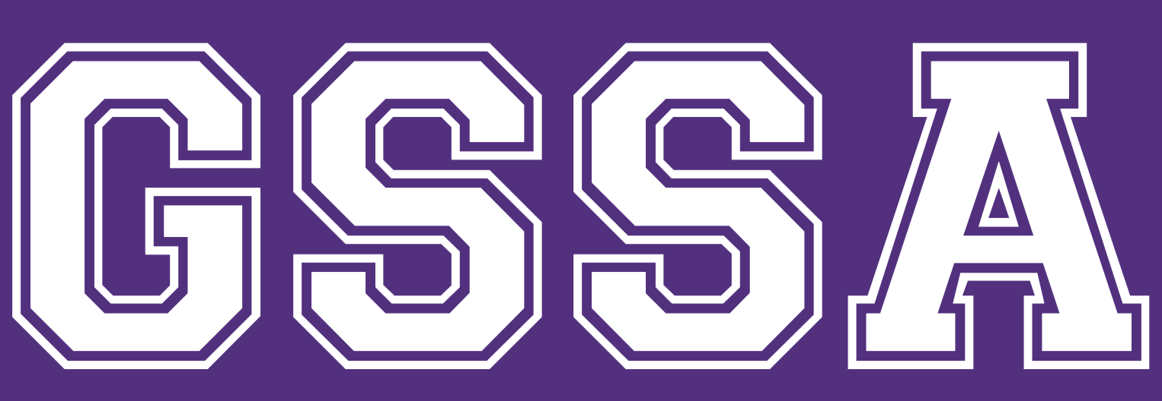

RHYTHMIC ONLINE TRAINING - WEEK 3 CHALLENGES!

Hi everyone!

Congratulations to our Week 2 Challenge winners! It was so fun to watch all your tik toks!

Challenges are activities or sets of exercises that you can do throughout the week, to earn stars on your virtual star chart! Prizes will be available once things get a little more back to normal! Coaches have been working hard to develop challenges that are age and level appropriate for all participants, and that will develop the girls’ physical abilities, apparatus handling, and increase their gymnastics knowledge!

Please note that all online training is optional, including the challenges. You can participate in as much or as little as you like.

Challenges will go live on the Monday of each week. Everyone will get a star for every online Zoom session they participate in with Mel. For any other challenges, please send your photos and videos in the following ways:
- Email to gssagym@gmail.com
- Post in the GSSA Rhythmic Gymnastics Squad Members facebook page
- Post on your instagram account, and tag gssa_gymnastics
- Private message your photos/videos on instagram to gssa_gymnastics
gymnastics centre
100 Argyle Street, South Windsor
(02) 4577 8789
gssagym@gmail.com
gssacentre.com.au
100 Argyle Street, South Windsor
(02) 4577 8789
gssagym@gmail.com
gssacentre.com.au

Here are our Week 3 Challenges! If you have any questions, please don’t hesitate to email gssagym@gmail.com, or contact Mel.

PHYSICAL CHALLENGE - RHYTHMIC SPECIFIC CONDITIONING

Rhythmic gymnastics requires development of a wide range of muscular abilities. We need muscles that are long, lean, flexible and strong! These exercises are designed to help improve your flexibility and muscle tone. Planet Rhythmics, a gymnastics club in Vancouver, Canada, have developed these great videos to help all rhythmic athletes train at home.

- Level 1 - 4 https://www.youtube.com/watch?v=os1ILqj2_e0&t=82s
- Level 5+ https://www.youtube.com/watch?v=_Os-3h-hewo

Stars awarded:
1 star for every time the challenge is performed (maximum 2 per day). Don’t forget to send us your evidence!
1 star if a family member attempts to do the set with you (Note: they participate at their own risk!)

KNOWLEDGE CHALLENGE - 2018 RHYTHMIC WORLD CHAMPIONSHIPS, HOOP FINAL

Click https://www.youtube.com/watch?v=o1GPMXWPwhg&t=188s and watch the hoop final from 2018 World Championships held in Sofia, Bulgaria. Many of these girls are aiming to qualify for the Tokyo 2021 Olympics. The video goes for about half an hour, and the commentary is not in English, so mute if you feel the need, but put the sound on to hear the music.

Have a go at answering the following questions! Mel has provided her answers to some and hints to others!

- Who was your favourite athlete to watch?

Mel: Not her best work here, but Vlada Nikolchenko (Ukraine). She was only 15 at these world championships!

2. What was your favourite leotard?

Mel: Dina Averina’s! So shiny!

3. What two big mistakes did Vlada Nikolchenko make?

Mel’s hint: Watch her body and her apparatus!

4. How many balances does Dina Averina (Russia) perform?

Mel’s hint: Combination balances are counted as two skills

5. How many leaps does Linoy Ashram (Israel) perform?

Mel’s hint: The same leap can be performed more than once if it is connected in a series.

For the brave: Count the apparatus difficulties in Arina Averina’s (Russia) routine!

Mel’s hint: The Russian gymnasts, and the Averina twins in particular, are known for their ability to pack difficulty in their routines!

Stars awarded:
Everyone who answers the questions will get 1 star!
The closest person to the correct answers will get an additional star!

APPARATUS CHALLENGE: RIBBON

Each squad will have a specific ribbon challenge this week. If you don’t have a ribbon at home, you can purchase a cheap one here https://www.onlinetoys.com.au/rainbow-ribbon-small.html?gclid=Cj0KCQjwybD0BRDyARIsACyS8msypekB2FSRI2dNBApNZQY5G4X4LF6b1c-VUp65Z8SQmezB8lcgGesaAlnBEALw_wcB

It may not arrive in time to participate in the challenge but will be great for at home practice in the future. In the mean time, wrist actions can be practiced by holding a pencil in the same grip.

Level 1 & 2: Large circles - don’t get wrapped up!
- Overhead circles
- Frontal circles
- Lateral circles

Level 3 & 4: Spirals
- Spirals in front of the body
- Spirals to the side of body
- Flower - spirals on the floor turning in circle

Level 5+: Echappes
- Overhead echappe
- Lateral echappe
- Horizontal echappe

Have a go at these ribbon apparatus difficulties (ADs). Everyone can have a try, they range from easy to hard!

https://www.instagram.com/p/B56QxQiBA7X/ - spirals on the floor, passing over

https://www.instagram.com/p/B23wNZoh23P/ - catch under leg kneeling on floor

https://www.instagram.com/p/BwbbJzRodoT/ - spirals under leg in rotation

https://www.instagram.com/p/BvkHXoWBKAv/ - catch out of sight, without the use of hands

https://www.instagram.com/p/Bvi_a42AxBW/ circles, in rotation, without hands, out of sight

Stars awarded:
Everyone who participates in the challenge will get 1 star!
Everyone who successfully completes an AD will get one star per AD performed

We encourage all gymnasts participating in our online training and challenges to be safe and consider the area around them before performing any gymnastics. Don’t forget to record your activities in your training tracker. All challenges will be run through in Tuesday online Zoom sessions with Mel to clear up any confusion.

If you post any online training on facebook or instagram, don’t forget to tag us!

